Learning RESTWEB API

1. Create Maven project with Jersy Framework archtypeas per the below video

<https://www.youtube.com/watch?v=skltzZH7i4w&index=11&list=PLqq-6Pq4lTTZh5U8RbdXq0WaYvZBz2rbn>

Open Eclipse-> New Project -> project-> Maven->Maven project

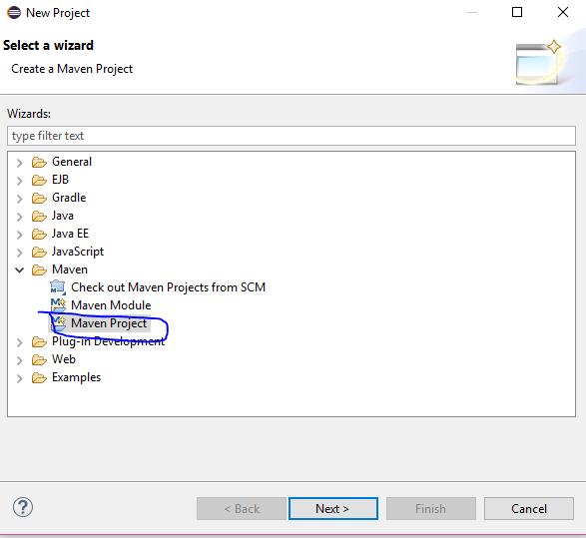

Click next

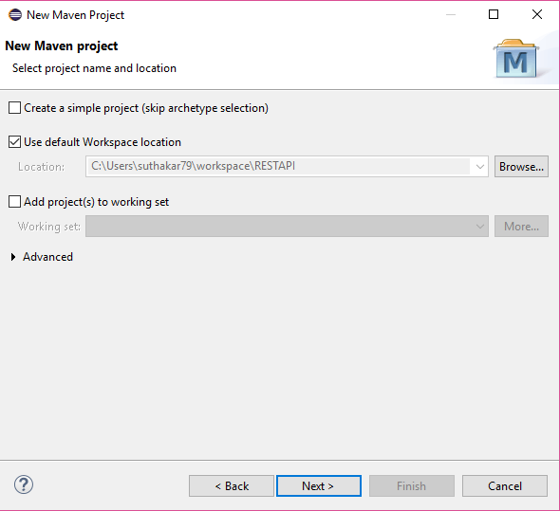

Click Next

Type Jersey into filter and you will get below screen

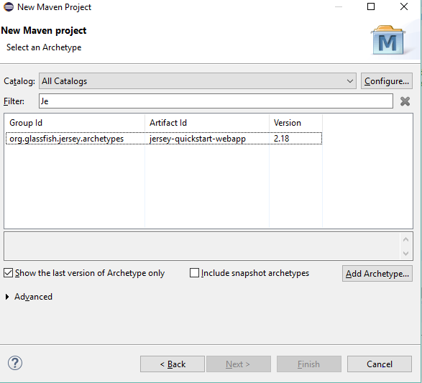

If you are not getting the group id then you can click Add Archetype button to add then type the Groupid and artifact id

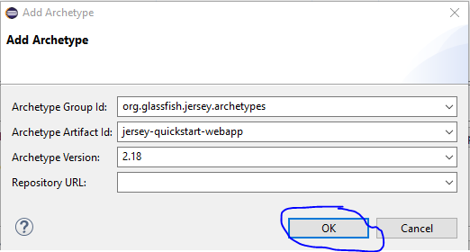

Then again type groupid and artifact id for the project you are going to create

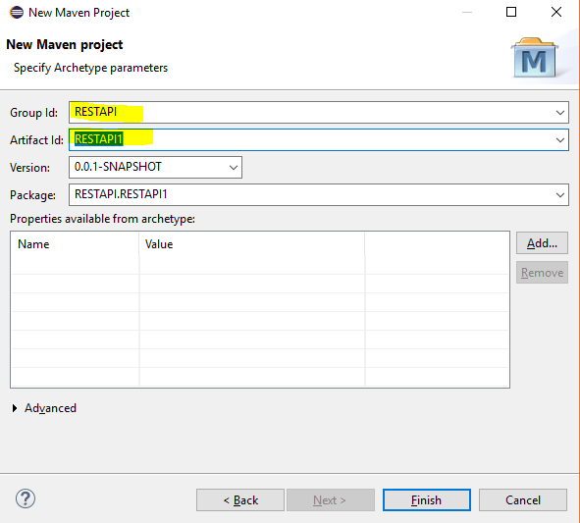

Then click finish, you are created and then install tomcat server

Please refer the above link to install and set it up.